CHADWICK FFA CHAPTER SHIRTS FOR SALE
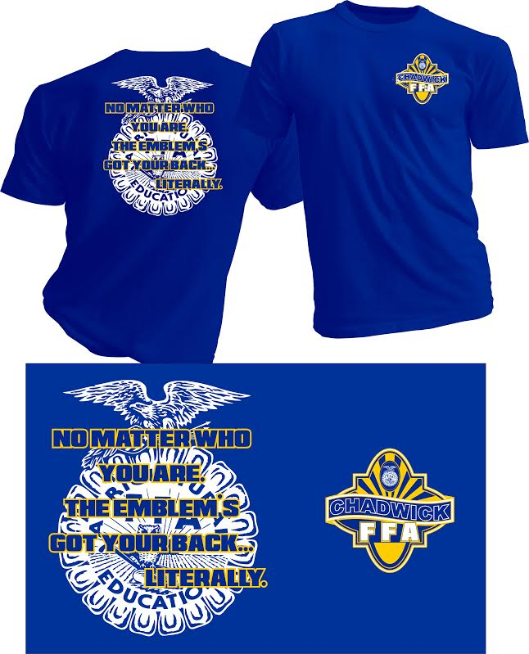
$10 PER SHIRT
SMALL ______ XL_______
MEDIUM ______ 2X_______ Youth Medium______
LARGE _______ 3X_______ Youth Large_______
Give this form along with payment to Mr. Holt in the Agriculture building or the front desk! Make checks payable to CHADWICK FFA.
Orders due by Wednesday, August 31!
***IF YOU PLAN ON JOINING FFA YOU WILL GET A SHIRT WITH YOUR MEMBERSHIP, DO NOT ORDER ONE***

